Doing the research took the longest but this was otherwise a pretty straight-forward exercise. I read up on what the Slack website itself had to say about using bots:

Creating bots for your workspace:

<https://slack.com/intl/en-za/help/articles/115005265703-Create-a-bot-for-your-workspace>

Building reply bots with Zapier:

<https://zapier.com/blog/how-to-build-chat-bot/>

Connect your bot with slack:

<https://www.chatbot.com/help/integrations/slack-integration/>

Review how bots work in slack:

<https://discover.bot/bot-talk/guide-to-messaging-apps-chatbot/slack/>

What is needed to build a bot:

<https://cdn.zapier.com/storage/learn_ebooks/24a8b8941d629f9c8997a1422ffa56e4.pdf>

Building apps for slack:

<https://api.slack.com/apps/A01HF6PUECA?created=1>

Enabling interactions with bots:

<https://api.slack.com/bot-users>

I decided to use Python to approach the problem. I found many guides for how to set up a Python environment such as <https://code.visualstudio.com/docs/python/python-tutorial>

and there were many guides for how to write the needed code such as <https://www.youtube.com/watch?v=KJ5bFv-IRFM>

Zapier wasn’t really needed after all. I just made a new workspace, connected the bot, copied the token, imported into Python and wrote a message as in the pic below:

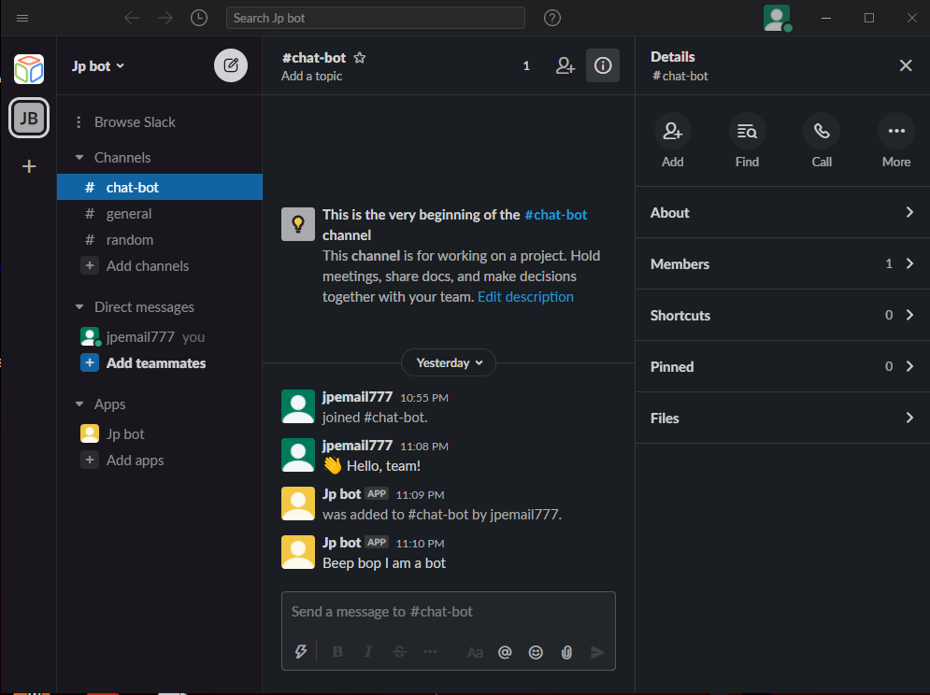

The python code is in bot.py and the .env file.